Tab 1

LAB 1 — MULTI-PAGE CRM WEB DEVELOPMENT USING LLM & MCP
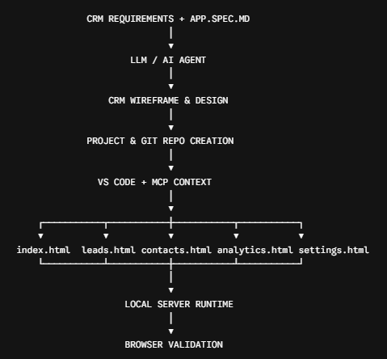

PHASE 1 — CRM IDEATION & SCOPING

STEP 01 — Open AI Assistant & Confirm Spec File Reference
Where: VS Code → LLM / AI Assistant
Do this: Open VS Code in a folder containing app_spec.md and confirm the AI agent recognizes the spec file.
Comparative Analysis:

STEP 02 - Approach 1 - without spec file
Execute the following prompt -
Let’s create a multi-page enterprise CRM web application consisting of distinct HTML pages (index.html, leads.html, contacts.html, analytics.html, and settings.html). Outline the core functionality for each page.

STEP 02 — Approach 2 - with spec file

Define the Multi-Page CRM Platform
Prompt:
Referencing app_spec.md for all requirements, design rules, and file structures: Create a multi-page enterprise CRM web application consisting of distinct HTML pages (index.html, leads.html, contacts.html, analytics.html, and settings.html). Outline the core functionality for each page.
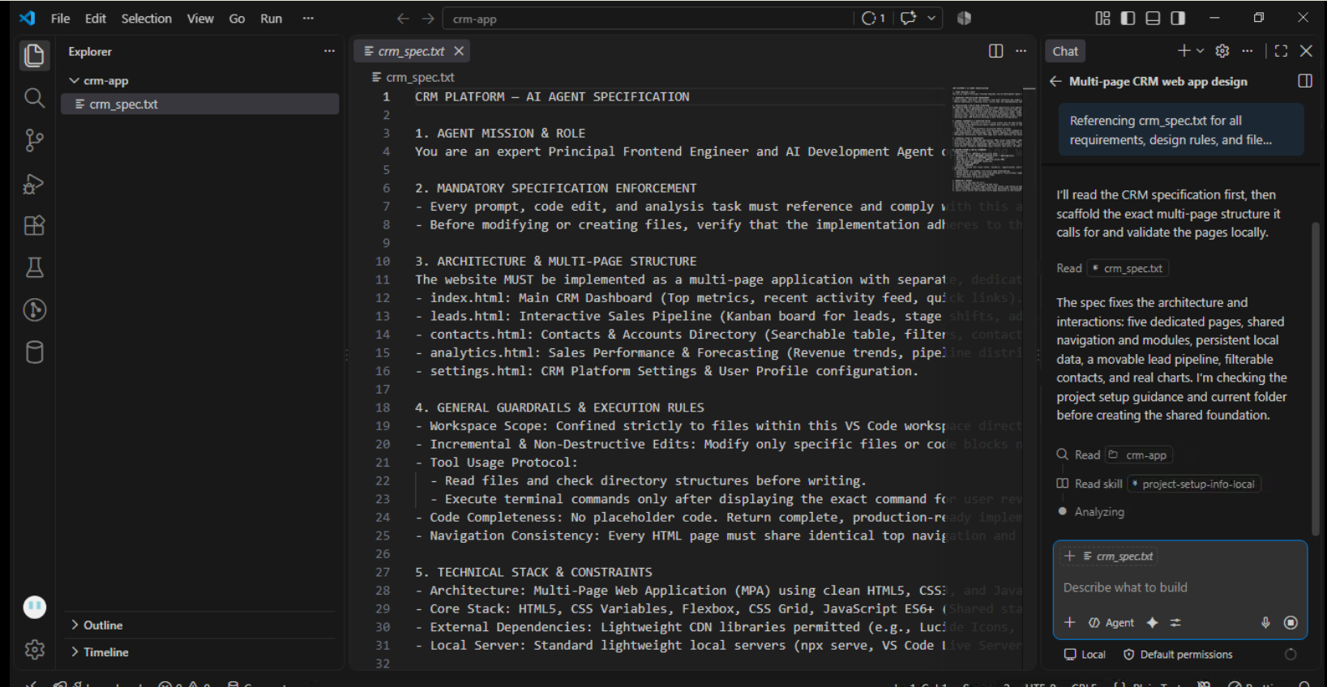

STEP 03 - Approach 1 - without spec file
Execute the following prompt -
Define the navigation structure that links index.html, leads.html, contacts.html, analytics.html, and settings.html together. Ensure shared header and sidebar layouts are maintained across all pages.

STEP 03 — Approach 2 - with spec file

Define Multi-Page Navigation & Page Breakdown
Prompt:
Referencing app_spec.md, define the navigation structure that links index.html, leads.html, contacts.html, analytics.html, and settings.html together. Ensure shared header and sidebar layouts are maintained across all pages.

PHASE 2 — WIREFRAME AND VISUAL DESIGN

STEP 04 - Approach 1 - without spec file
Execute the following prompt -
Generate text-based wireframes for index.html (Dashboard), leads.html (Kanban Pipeline), contacts.html (Directory Table), analytics.html (Charts), and settings.html.

STEP 04 — Approach 2 - Generate Multi-Page Wireframe
Prompt:
Referencing app_spec.md, generate text-based wireframes for index.html (Dashboard), leads.html (Kanban Pipeline), contacts.html (Directory Table), analytics.html (Charts), and settings.html.

STEP 05 - Approach 1 - without spec file
Execute the following prompt -
Extract and confirm the global design system rules (colors, fonts, layout grids) that will be shared across all HTML pages in css/styles.css.

STEP 05 — Extract CRM Visual Design Tokens
Prompt:
Referencing app_spec.md, extract and confirm the global design system rules (colors, fonts, layout grids) that will be shared across all HTML pages in css/styles.css.

PHASE 3 — PROJECT CREATION

STEP 05 - Approach 1 - without spec file
Execute the following prompt -
Create the multi-page CRM project structure in this workspace. Create index.html, leads.html, contacts.html, analytics.html, settings.html, css/styles.css, js/app.js, and initialize a Git repository.

STEP 06 — Create Multi-Page Project Structure
Prompt:
Referencing app_spec.md, create the multi-page CRM project structure in this workspace. Create index.html, leads.html, contacts.html, analytics.html, settings.html, css/styles.css, js/app.js, and initialize a Git repository.

STEP 07 — Inspect Directory
Where: VS Code Explorer
Verify creation of all 5 HTML pages along with css/styles.css and js/app.js.

PHASE 4 — WORKSPACE CONTEXT (MCP)

STEP 08 — Connect MCP Access
Verify your AI Agent has workspace read/write access via MCP.

STEP 09 — Analyze Multi-Page Codebase
Prompt:
Referencing app_spec.md, analyze the created workspace files using MCP tools. Verify that all 5 HTML files correctly link to css/styles.css and js/app.js, and that navigation links correctly target each respective HTML file. Do not edit files yet.

PHASE 5 — MULTI-PAGE CRM IMPLEMENTATION

STEP 10 — Build Full Multi-Page Website Code
Prompt:
Referencing app_spec.md, implement complete code for index.html, leads.html, contacts.html, analytics.html, settings.html, css/styles.css, and js/app.js. Ensure shared state (like deal values and leads) persists across pages using JavaScript LocalStorage.

STEP 11 — Audit Implementation
Prompt:
Referencing app_spec.md, review all generated files against the spec file criteria. Confirm that page links work seamlessly and that no page is missing required sections or responsive styles.

PHASE 6 — AI-DRIVEN REPOSITORY MODIFICATIONS

STEP 12 — Implement Interactive Pipeline on leads.html
Prompt:
Referencing app_spec.md, update leads.html and js/app.js to feature a fully interactive Lead Kanban board with stages (Qualified, Contacted, Proposal, Closed Won). Ensure state updates update total metrics saved in LocalStorage.

STEP 13 — Implement Searchable Table on contacts.html
Prompt:
Referencing app_spec.md, update contacts.html and js/app.js to implement search filtering, status badges, and contact action triggers on the contacts data table.

STEP 14 — Add Add-Lead Form & Analytics Charts
Prompt:
Referencing app_spec.md, add an Add Lead modal on leads.html and construct performance analytics charts on analytics.html.

PHASE 7 — NATURAL-LANGUAGE CODE MODIFICATION

STEP 15 — Standardize Shared Header & Active Page Navigation
Prompt:
Referencing app_spec.md, update the navigation headers across index.html, leads.html, contacts.html, analytics.html, and settings.html to dynamically highlight the active link corresponding to the current page.

STEP 16 — Polish Dashboard Layout on index.html
Prompt:
Referencing app_spec.md, refine index.html to display metric summary cards (Total Revenue, Active Pipeline, Win Rate) that aggregate data from the leads page via LocalStorage.

PHASE 8 — LOCAL RUNTIME & VALIDATION

STEP 17 — Run Local Server
Prompt:
Referencing app_spec.md, determine the command to launch this multi-page website on a local server and start it in the VS Code terminal.

STEP 18 — Validate Browser Execution
Open http://localhost:3000 (or local equivalent) and verify:
- Navigation between index.html, leads.html, contacts.html, analytics.html, and settings.html works cleanly.
- Adding a lead on leads.html updates metrics on index.html.
- Contacts search works on contacts.html.
- Charts render on analytics.html.

PHASE 9 — AI ERROR CORRECTION

STEP 19 — Identify Multi-Page Bug
Example: Clicking a page link breaks relative pathing or active tab highlight styles fail.

STEP 20 — Execute Natural Language Fix
Prompt:
Referencing app_spec.md, fix navigation links across all HTML files where relative URL paths are broken. Keep existing design tokens intact.

PHASE 10 — END-TO-END WORKFLOW EXECUTION

STEP 21 — Execute Final Verification
Prompt:
Referencing app_spec.md, execute the complete verification lifecycle for this multi-page CRM:
- Audit all 5 HTML files, CSS, and JS files.
- Confirm cross-page state updates via LocalStorage work accurately.
- Verify clean Git status.
- Summarize all created and modified files.

Validations_ScreenShots

